Seychelles

## Political Stability Estimate Data

The data set shows the political stability estimate of the country each year.

## # A tibble: 19 x 5  
## country iso3c date stability stabilityCategory4  
## <chr> <chr> <dbl> <dbl> <chr>   
## 1 Seychelles SYC 1996 1.05 highly stable   
## 2 Seychelles SYC 1998 1.08 highly stable   
## 3 Seychelles SYC 2000 1.28 highly stable   
## 4 Seychelles SYC 2002 0.902 moderately stable   
## 5 Seychelles SYC 2003 0.646 moderately stable   
## 6 Seychelles SYC 2004 0.657 moderately stable   
## 7 Seychelles SYC 2005 0.933 moderately stable   
## 8 Seychelles SYC 2006 0.914 moderately stable   
## 9 Seychelles SYC 2007 0.788 moderately stable   
## 10 Seychelles SYC 2008 0.750 moderately stable   
## 11 Seychelles SYC 2009 0.599 moderately stable   
## 12 Seychelles SYC 2010 0.857 moderately stable   
## 13 Seychelles SYC 2011 0.938 moderately stable   
## 14 Seychelles SYC 2012 0.744 moderately stable   
## 15 Seychelles SYC 2013 0.826 moderately stable   
## 16 Seychelles SYC 2014 0.362 moderately stable   
## 17 Seychelles SYC 2015 0.689 moderately stable   
## 18 Seychelles SYC 2016 0.733 moderately stable   
## 19 Seychelles SYC 2017 0.677 moderately stable

## Political Stability Estimate Plot

The plot shows the trends of stabilization and destabilization for the each country.

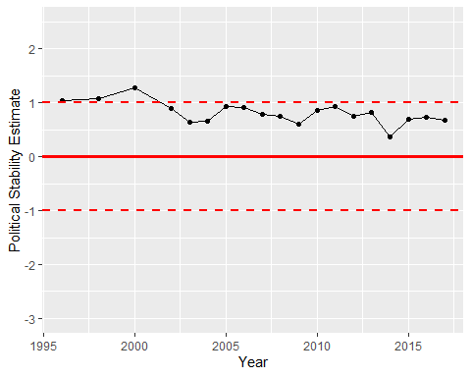

Political Stability Trend